**FlexLM App**

**Summer 2019**

**Abstract**

Large manufacturing, technology, and research organizations rely on expensive software to help their employees run simulations and computations. These software packages are expensive and employees often use 10 or more licenses at once to run simulations and calculations. Businesses are challenged to ensure that they purchase enough licenses for their engineers and developers but not too much to incur idle unused licenses. Capacity planning for businesses is very difficult due to the lack of historical data analysis of how the licenses are utilized. This capacity planning for organizations is essential in order to justify the need to increase or decrease licenses based on historical license log data.

The flexLM app that will help companies analyze license usage across various applications in flexLM. This app is able to ingest data from this license management solution, and give businesses insight into their license usage. This includes being able to view which licenses are being used the most often, which ones are not being utilized, and which licenses are idle and wasting money. The app will help institutions visualize how much money they are losing due to idle and underutilized licenses and will aid them in capacity planning for future terms.

**Configuring**

1. Download the flexlmv2.tar file
2. Upload the app to Splunk
   1. Click on Apps → Manage apps → Install app from file
   2. Upload the .tar file
3. Getting data in
   1. Select Source
      1. Select license logs
   2. Select source type
      1. Sourcetype: flexLM
      2. Important Note
         1. Splunk will assign the timestamp based off of the last date event that occurs in the logs, and then use the timestamp in the event for hours and minutes
         2. Example date event:
            1. 20:37:12 (lmgrd) TIMESTAMP 8/14/2019
   3. Input settings
      1. Index = flexlmtest

**Eventgen**

**\***Instructions on how to get eventgen configured if needed

1. Samples file
   1. If not already in the flexlmv2 app → create a samples directory
   2. Place the logs you want to replay in the file
      1. Important note
         1. I was only able to get eventgen to run by uploading the logs I have into Splunk → exporting the data as a csv → putting this csv in samples
2. Eventgen.conf
   1. Place this file into the local directory (create one if not there already)
   2. Example
      1. 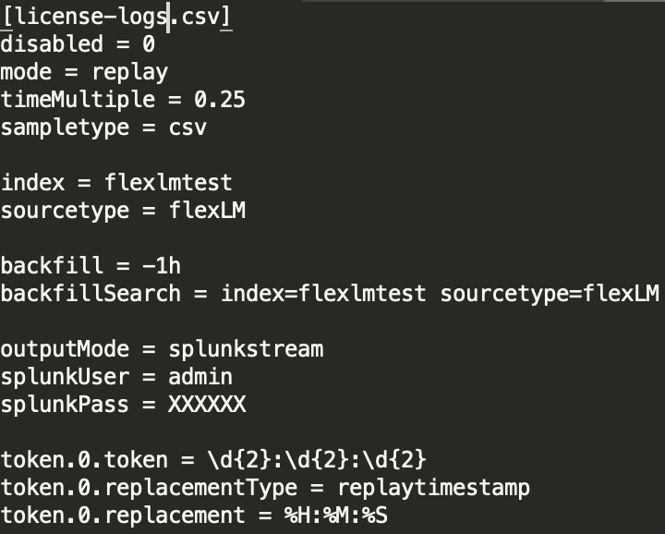
      2. *Remember to replace splunkPass with your actual password
3. Eventgen
   1. Download the Eventgen app off of SplunkBase
   2. Go to settings → data inputs → SA-Eventgen
      1. Make sure status is **enabled**
   3. Go to apps → manage apps → find SA-Eventgen and flexlm
      1. Under the sharing column, make sure both permissions are set to global
4. Restart Splunk

**Overview**

1. License Manager - Main
   1. High level overview
   2. Shows what is being used
2. Detailed software usage investigator
   1. Investigative tool to examine by software/user/license server and time
3. Software usage durations
   1. Examines the number of periods that software licenses are in use
4. Idle returned licenses
   1. Look for users who have held onto licenses without using them
   2. You are able to automate this to report that you have licenses checked out
5. flexLM timeline
   1. Provide a way to investigate software usage for a specific user and look for idle timeouts
6. Denial usage investigator
   1. Investigate denials
   2. Specify how many denials and over what timeframe to examine for them
7. License Utilization
   1. View license data in terms of license term agreement
   2. Visualize an estimate of how much money you are losing per term due to idle and unused licenses
   3. Capacity planning
      1. See which licenses have untouched packages and which ones have the most denials
   4. License term agreement
      1. Visualize the details of your license agreement
      2. Upload a csv as an inputlookup